XTERN R Code
10/17/2021
#First read in the table containg resturant info
resturantData=read.table("TechPointresturant.csv", sep=",",quote = "\"", header=T)
#resturantData
dim(resturantData)
## [1] 81 5
head(resturantData)
## Name Lat Lng Rating Price_Lev
## 1 Mama Carolla's 39.85086 -86.14085 4.7 2
## 2 Yats 39.85062 -86.14553 4.8 1
## 3 The Jazz Kitchen 39.85084 -86.14558 4.7 2
## 4 Twenty Tap 39.85130 -86.14612 4.7 2
## 5 Good Morning Mama's Cafe 39.85078 -86.14133 4.5 2
## 6 Napolese Pizzeria 39.84283 -86.15417 4.5 2
#Now let's remove the data where the price_level is too low or too high
#Note price level is determined on a scale from 1-4
#This means we only want to keep restaurants with a price level of 2 or 3
#We also want to remove any rows of data that are missing a rating or price level
limitData = resturantData[resturantData$Price_Lev != 1 & resturantData$Price_Lev != 4 & resturantData$Price_Lev != 'none' & resturantData$Rating != 'N/A', ]
dim(limitData)
## [1] 52 5
# We are now down to 52 restaurants
#Now let's sort the data by Rating (from highest to lowest)
sortedData=limitData[with(limitData, order(-as.double(limitData$Rating))), ]
#Now we will keep only the top 20 restaurants as possible options for Group Dinners
Top20 = sortedData[1:20,]
Top20
## Name Lat Lng Rating
## 1 Mama Carolla's 39.85086 -86.14085 4.7
## 3 The Jazz Kitchen 39.85084 -86.14558 4.7
## 4 Twenty Tap 39.85130 -86.14612 4.7
## 21 The Friendly Tavern 39.94917 -86.26139 4.7
## 39 Convivio Italian Artisan Cuisine - Zionsville 39.95115 -86.26215 4.7
## 8 Delicia 39.84738 -86.14528 4.6
## 9 Diavola 39.85139 -86.13889 4.6
## 10 Greek's Pizzeria 39.84303 -86.14540 4.6
## 15 Fat Dan's Deli 39.85138 -86.14611 4.6
## 23 Cobblestone 39.95027 -86.26177 4.6
## 25 Noah Grant's Grill House & Oyster Bar 39.95087 -86.26161 4.6
## 26 Rosie's Place 39.95126 -86.26218 4.6
## 28 The Scoop 39.94894 -86.26089 4.6
## 33 Books & Brews - Zionsville 39.95180 -86.27817 4.6
## 53 Smoothie King 39.95752 -86.01316 4.6
## 55 Another Broken Egg Cafe 39.95724 -86.01671 4.6
## 65 Fogo de Chão Brazilian Steakhouse 39.76679 -86.15569 4.6
## 73 Chatham Tap Mass Ave 39.77663 -86.14638 4.6
## 79 Iozzo's Garden of Italy 39.75424 -86.15945 4.6
## 5 Good Morning Mama's Cafe 39.85078 -86.14133 4.5
## Price_Lev
## 1 2
## 3 2
## 4 2
## 21 2
## 39 2
## 8 2
## 9 2
## 10 2
## 15 2
## 23 2
## 25 3
## 26 2
## 28 2
## 33 2
## 53 2
## 55 2
## 65 3
## 73 2
## 79 2
## 5 2
dim(Top20)
## [1] 20 5
#Now let's write these top 20 restaurants to a table
write.table(Top20,"topResturants.csv",sep=",",row.names=FALSE)
#Now let's read in our finalized datatable
data=read.table("theLocationData.csv",sep=",",quote="\"",header=T)
#data
dim(data)
## [1] 27 7
#note there are 27 rows because we currently have 20 restaurants
#Now let's add another column/variable to keep track of "type" of location in each row
type<-c("sport","art","sport","music","conference","gaming","resturant","resturant","resturant","resturant","resturant","resturant","resturant","resturant","resturant","resturant","resturant","resturant","resturant","resturant","resturant","resturant","resturant","resturant","resturant","resturant","housing")
#type
#Let's add the type variable to our dataset
data$type <- type
#data
#It is now time to remove the extra 10 restaurants
#This means we will remove 10 rows
#The decision for which restaurants I chose to keep out of the top 20 was decided by yelp reviews and restaurant types
# 1 we will remove row 26 Good Morning Mama's Cafe (it's a breakfast restaurant)
# 2 we will remove row 22 Another Broken Egg Cafe (breakfast)
# 3 we will remove row 21 Smoothie King (breakfast)
# 4 we will remove row 20 books & brews
# 5 we will remove row 19 the scoop (ice cream)
# 6 we will remove row 18 Rosie's place (only breakfast and lunch)
# 7 we will remove row 17 Noah Grant's Grill House (not enough menu variety)
# 8 we will remove row 23 Fogo de Chao (more expensive)
# 9 we will remove row 14 Greek's Pizza because Diavola is also a pizza place
#10 we will remove row 25 because we already have 2 other Italian restaurants
#Now we will remove the above rows
data<- data[-c(14,17,18,19,20,21,22,23,25,26),]
dim(data)
## [1] 17 8
#Note now our data only contains 17 rows (the 6 events, housing, and 10 resturants)
#Here we will do some quick summary/descriptive stats
#Change all of the variable types
data$type = as.factor(data$type)
data$HousingDist=as.double(data$HousingDist)
data$CoWork1Dist=as.double(data$CoWork1Dist)
data$CoWork2Dist=as.double(data$CoWork2Dist)
data$CoWork3Dist=as.double(data$CoWork3Dist)
data$CoWork4Dist=as.double(data$CoWork4Dist)
data$CoWork5Dist=as.double(data$CoWork5Dist)
summary(data)
## Location.Name HousingDist CoWork1Dist CoWork2Dist
## Length:17 Min. : 0.000 Min. : 0.200 Min. : 0.0714
## Class :character 1st Qu.: 2.600 1st Qu.: 0.400 1st Qu.:13.6000
## Mode :character Median : 6.900 Median : 5.200 Median :13.9000
## Mean : 6.665 Mean : 5.735 Mean :13.0042
## 3rd Qu.: 7.400 3rd Qu.: 7.400 3rd Qu.:18.0000
## Max. :17.300 Max. :14.300 Max. :18.5000
##
## CoWork3Dist CoWork4Dist CoWork5Dist type
## Min. :12.0 Min. : 1.100 Min. : 0.800 art : 1
## 1st Qu.:12.4 1st Qu.: 1.800 1st Qu.: 2.400 conference: 1
## Median :19.2 Median : 6.400 Median : 7.000 gaming : 1
## Mean :17.2 Mean : 6.606 Mean : 6.853 housing : 1
## 3rd Qu.:20.7 3rd Qu.: 6.800 3rd Qu.: 7.300 music : 1
## Max. :22.8 Max. :17.800 Max. :17.900 resturant :10
## sport : 2
#make sure we have no missing data
which(is.na(data)==TRUE)
## integer(0)
#data
require(ggplot2)
## Loading required package: ggplot2
## Registered S3 methods overwritten by 'tibble':
## method from
## format.tbl pillar
## print.tbl pillar
#Here are some initial plots of the data
ggplot(data,aes(x=HousingDist,y=CoWork1Dist,color=type))+geom_point()+facet_wrap(~type,ncol=2)
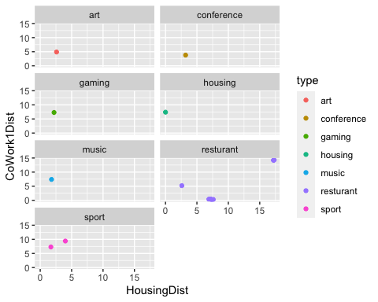
ggplot(data,aes(x=HousingDist,y=CoWork2Dist,color=type))+geom_point()+facet_wrap(~type,ncol=2)
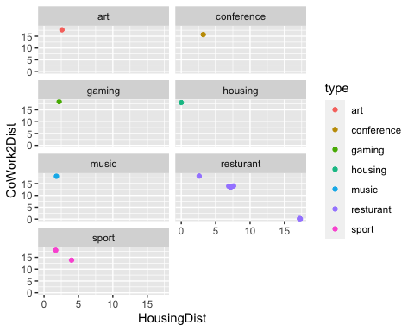
ggplot(data,aes(x=HousingDist,y=CoWork3Dist,color=type))+geom_point()+facet_wrap(~type,ncol=2)
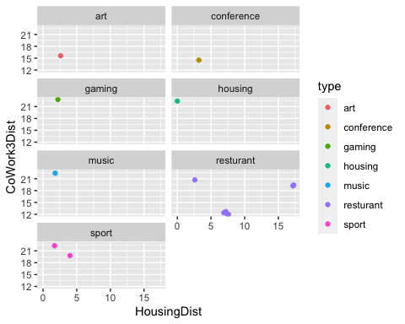
ggplot(data,aes(x=HousingDist,y=CoWork4Dist,color=type))+geom_point()+facet_wrap(~type,ncol=2)
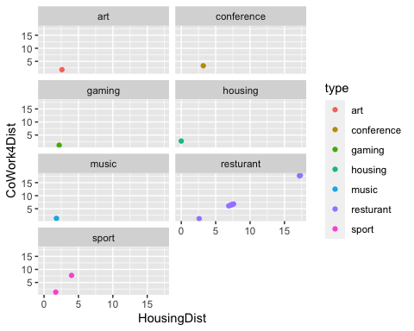
ggplot(data,aes(x=HousingDist,y=CoWork5Dist,color=type))+geom_point()+facet_wrap(~type,ncol=2)
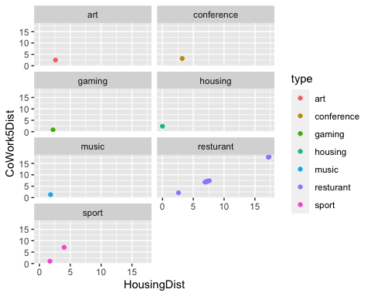
#Now we will begin our Cluster Analysis
#We will be using kmeans clustering
#data
#First we must remove the "name/location" column from the data
newData = data[,2:8]
#newData
#now we must ensure all columns are numeric
newData$type=as.numeric(newData$type)
#newData
#now let's start kmeans clustering!
require(cluster)
## Loading required package: cluster
set.seed(12456)
newData<-na.omit(newData)
kmn2=kmeans(newData,2)
kmn2
## K-means clustering with 2 clusters of sizes 8, 9
##
## Cluster means:
## HousingDist CoWork1Dist CoWork2Dist CoWork3Dist CoWork4Dist CoWork5Dist type
## 1 2.26250 6.587500 17.262500 20.06250 2.55000 2.55000 4.375
## 2 10.57778 4.977778 9.219044 14.65556 10.21111 10.67778 6.000
##
## Clustering vector:
## 1 2 3 4 5 6 7 8 9 10 11 12 13 15 16 24 27
## 1 1 1 1 1 1 2 2 2 2 2 2 2 2 2 1 1
##
## Within cluster sum of squares by cluster:
## [1] 225.280 1536.216
## (between_SS / total_SS = 41.3 %)
##
## Available components:
##
## [1] "cluster" "centers" "totss" "withinss" "tot.withinss"
## [6] "betweenss" "size" "iter" "ifault"
kmn2$tot.withinss
## [1] 1761.496
TWSS = array(0,16)
for(i in 1:16){
kmn=kmeans(newData, i)
TWSS[i]=kmn$tot.withinss
}
#TWSS
k=1:16
plot(k,TWSS,type="b",pch=16)
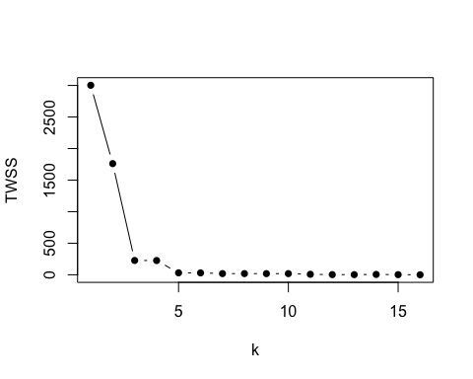
## Based on the plot there doesn't appear to be signficant change after k = 4 so we will chose k = 4 for our kmeans clustering
Kmn4=kmeans(newData,4)
#Kmn4
#Now let's explore the results of this clustering!
Kmn4$cluster
## 1 2 3 4 5 6 7 8 9 10 11 12 13 15 16 24 27
## 4 4 1 1 4 1 2 2 2 3 3 2 2 2 3 1 1
## "Rows belong to cluster 1:"
Clus1Rows=which(Kmn4$cluster==1)
print("Rows belong to cluster 1: ")
## [1] "Rows belong to cluster 1: "
Clus1Rows
## 3 4 6 24 27
## 3 4 6 16 17
#Rows belonging to cluster 2
Clus2Rows=which(Kmn4$cluster==2)
print("Rows belong to cluster 2: ")
## [1] "Rows belong to cluster 2: "
Clus2Rows
## 7 8 9 12 13 15
## 7 8 9 12 13 14
#Rows belonging to cluster 3
Clus3Rows=which(Kmn4$cluster==3)
print("Rows belong to cluster 3: ")
## [1] "Rows belong to cluster 3: "
Clus3Rows
## 10 11 16
## 10 11 15
#Rows belonging to cluster 4
Clus4Rows=which(Kmn4$cluster==4)
print("Rows belong to cluster 4: ")
## [1] "Rows belong to cluster 4: "
Clus4Rows
## 1 2 5
## 1 2 5
#Now let's seperate the original datset based on cluster
Cluster1Data=newData[Clus1Rows,]
Cluster2Data=newData[Clus2Rows,]
Cluster3Data=newData[Clus3Rows,]
Cluster4Data=newData[Clus4Rows,]
Cluster1Data
## HousingDist CoWork1Dist CoWork2Dist CoWork3Dist CoWork4Dist CoWork5Dist type
## 3 1.7 7.3 18.0 22.3 1.3 1.0 7
## 4 1.8 7.4 18.1 22.4 1.3 1.3 5
## 6 2.2 7.3 18.5 22.8 1.1 0.8 3
## 24 2.6 5.2 18.2 20.7 1.2 2.1 6
## 27 0.0 7.4 18.1 22.4 2.7 2.4 4
Cluster2Data
## HousingDist CoWork1Dist CoWork2Dist CoWork3Dist CoWork4Dist CoWork5Dist type
## 7 7.4 0.2 13.9 12.1 6.7 7.3 6
## 8 7.2 0.4 13.6 12.7 6.4 7.0 6
## 9 7.2 0.4 13.6 12.4 6.4 7.1 6
## 12 6.9 0.4 13.9 12.4 6.1 6.8 6
## 13 7.6 0.3 14.0 12.0 6.8 7.4 6
## 15 7.2 0.4 13.6 12.4 6.4 7.1 6
Cluster3Data
## HousingDist CoWork1Dist CoWork2Dist CoWork3Dist CoWork4Dist CoWork5Dist type
## 10 17.2 14.2 0.2000 19.2 17.6 17.7 6
## 11 17.3 14.3 0.0714 19.4 17.8 17.9 6
## 16 17.2 14.2 0.1000 19.3 17.7 17.8 6
Cluster4Data
## HousingDist CoWork1Dist CoWork2Dist CoWork3Dist CoWork4Dist CoWork5Dist type
## 1 4.0 9.4 13.8 19.8 7.7 7.1 7
## 2 2.6 4.9 17.7 15.6 1.8 2.5 1
## 5 3.2 3.8 15.7 14.5 3.3 3.2 2
Cluster1Data$type=as.factor(Cluster1Data$type)
summary(Cluster1Data)
## HousingDist CoWork1Dist CoWork2Dist CoWork3Dist CoWork4Dist
## Min. :0.00 Min. :5.20 Min. :18.00 Min. :20.70 Min. :1.10
## 1st Qu.:1.70 1st Qu.:7.30 1st Qu.:18.10 1st Qu.:22.30 1st Qu.:1.20
## Median :1.80 Median :7.30 Median :18.10 Median :22.40 Median :1.30
## Mean :1.66 Mean :6.92 Mean :18.18 Mean :22.12 Mean :1.52
## 3rd Qu.:2.20 3rd Qu.:7.40 3rd Qu.:18.20 3rd Qu.:22.40 3rd Qu.:1.30
## Max. :2.60 Max. :7.40 Max. :18.50 Max. :22.80 Max. :2.70
## CoWork5Dist type
## Min. :0.80 3:1
## 1st Qu.:1.00 4:1
## Median :1.30 5:1
## Mean :1.52 6:1
## 3rd Qu.:2.10 7:1
## Max. :2.40
Cluster2Data$type=as.factor(Cluster2Data$type)
summary(Cluster2Data)
## HousingDist CoWork1Dist CoWork2Dist CoWork3Dist CoWork4Dist
## Min. :6.90 Min. :0.200 Min. :13.60 Min. :12.00 Min. :6.100
## 1st Qu.:7.20 1st Qu.:0.325 1st Qu.:13.60 1st Qu.:12.18 1st Qu.:6.400
## Median :7.20 Median :0.400 Median :13.75 Median :12.40 Median :6.400
## Mean :7.25 Mean :0.350 Mean :13.77 Mean :12.33 Mean :6.467
## 3rd Qu.:7.35 3rd Qu.:0.400 3rd Qu.:13.90 3rd Qu.:12.40 3rd Qu.:6.625
## Max. :7.60 Max. :0.400 Max. :14.00 Max. :12.70 Max. :6.800
## CoWork5Dist type
## Min. :6.800 6:6
## 1st Qu.:7.025
## Median :7.100
## Mean :7.117
## 3rd Qu.:7.250
## Max. :7.400
Cluster3Data$type=as.factor(Cluster3Data$type)
summary(Cluster3Data)
## HousingDist CoWork1Dist CoWork2Dist CoWork3Dist
## Min. :17.20 Min. :14.20 Min. :0.0714 Min. :19.20
## 1st Qu.:17.20 1st Qu.:14.20 1st Qu.:0.0857 1st Qu.:19.25
## Median :17.20 Median :14.20 Median :0.1000 Median :19.30
## Mean :17.23 Mean :14.23 Mean :0.1238 Mean :19.30
## 3rd Qu.:17.25 3rd Qu.:14.25 3rd Qu.:0.1500 3rd Qu.:19.35
## Max. :17.30 Max. :14.30 Max. :0.2000 Max. :19.40
## CoWork4Dist CoWork5Dist type
## Min. :17.60 Min. :17.70 6:3
## 1st Qu.:17.65 1st Qu.:17.75
## Median :17.70 Median :17.80
## Mean :17.70 Mean :17.80
## 3rd Qu.:17.75 3rd Qu.:17.85
## Max. :17.80 Max. :17.90
Cluster4Data$type=as.factor(Cluster4Data$type)
summary(Cluster4Data)
## HousingDist CoWork1Dist CoWork2Dist CoWork3Dist
## Min. :2.600 Min. :3.800 Min. :13.80 Min. :14.50
## 1st Qu.:2.900 1st Qu.:4.350 1st Qu.:14.75 1st Qu.:15.05
## Median :3.200 Median :4.900 Median :15.70 Median :15.60
## Mean :3.267 Mean :6.033 Mean :15.73 Mean :16.63
## 3rd Qu.:3.600 3rd Qu.:7.150 3rd Qu.:16.70 3rd Qu.:17.70
## Max. :4.000 Max. :9.400 Max. :17.70 Max. :19.80
## CoWork4Dist CoWork5Dist type
## Min. :1.800 Min. :2.500 1:1
## 1st Qu.:2.550 1st Qu.:2.850 2:1
## Median :3.300 Median :3.200 7:1
## Mean :4.267 Mean :4.267
## 3rd Qu.:5.500 3rd Qu.:5.150
## Max. :7.700 Max. :7.100
Cluster=(as.factor(Kmn4$cluster))
#types<- list('1'="Sport",'2'="Art",'3'="Music",'4'="Conference",
#'5'="Gaming",'6'="Resturant",'7'="Housing"
ggplot(newData, aes(x=type, y=HousingDist,color=Cluster))+geom_point()
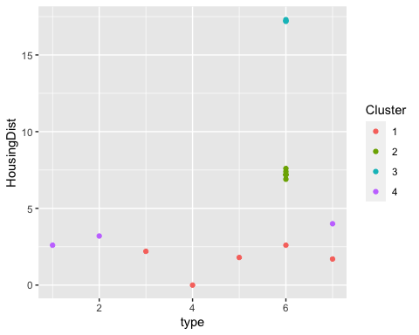
ggplot(newData, aes(x=type, y=CoWork1Dist,color=Cluster))+geom_point()
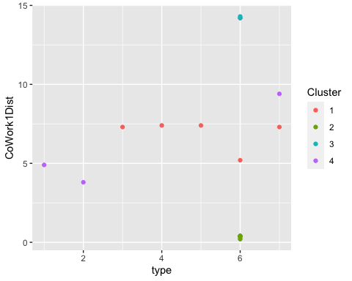
#most events appear to be a moderate distance away from coWorking Location 1
ggplot(newData, aes(x=type, y=CoWork2Dist,color=Cluster))+geom_point()
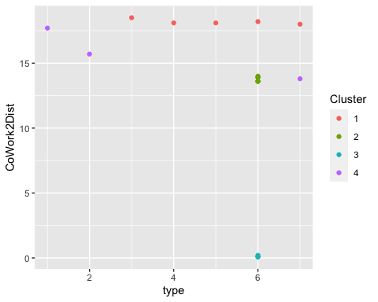
#almos all events seem very far from coWorking Location 2
ggplot(newData, aes(x=type, y=CoWork3Dist,color=Cluster))+geom_point()
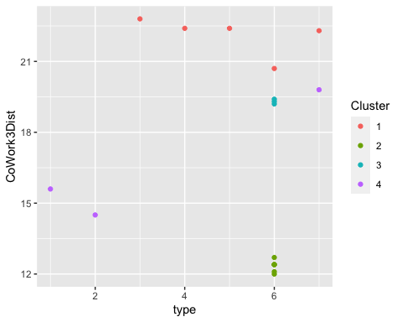
#some events some events are close to the coWorking location 3 but others are much further
ggplot(newData, aes(x=type, y=CoWork4Dist,color=Cluster))+geom_point()
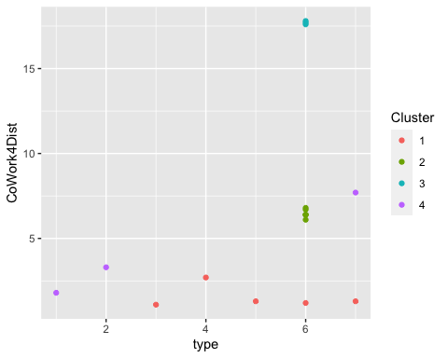
#Nearly all events are close to coWorking location 4 implying that coWorking location 4 might be the most convenient
ggplot(newData, aes(x=type, y=CoWork5Dist,color=Cluster))+geom_point()
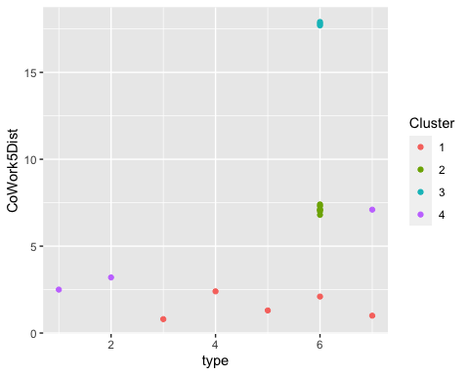
#Most events are close to Co Working location 5 implying that this location might also be convenient
ggplot(newData, aes(x=HousingDist,color=Cluster))+geom_histogram(bins=30)
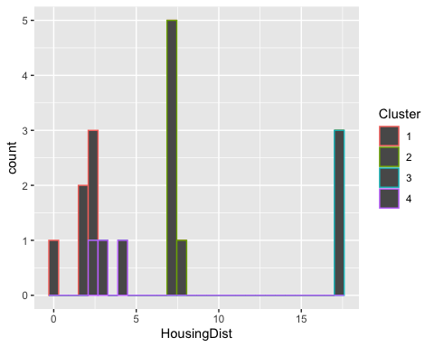
ggplot(newData, aes(x=CoWork1Dist,color=Cluster))+geom_histogram(bins=30)
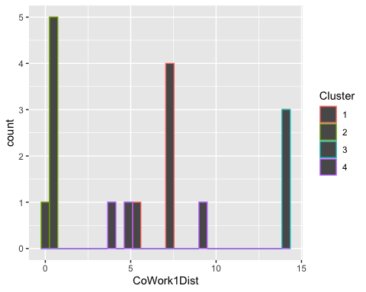
ggplot(newData, aes(x=CoWork2Dist,color=Cluster))+geom_histogram(bins=30)
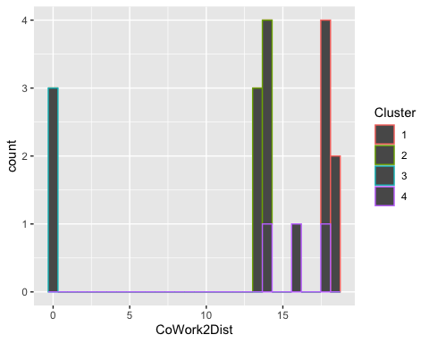
ggplot(newData, aes(x=CoWork3Dist,color=Cluster))+geom_histogram(bins=30)
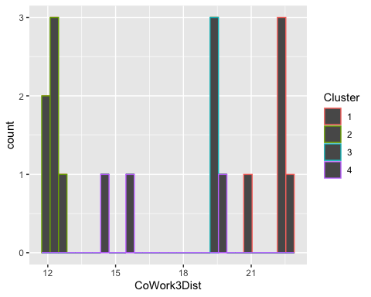
ggplot(newData, aes(x=CoWork4Dist,color=Cluster))+geom_histogram(bins=30)
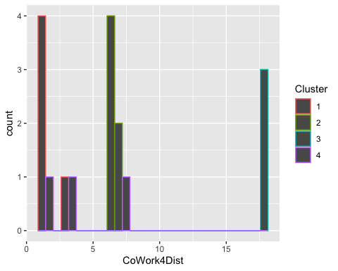
#four is looking to be preferable
ggplot(newData, aes(x=CoWork5Dist,color=Cluster))+geom_histogram(bins=30)



